**WARNING! SAFETY RELATED PARTS MUST ONLY BE FITTED/CHECKED BY TRAINED TECHNICIAN**

***TECbikepartsUSA.com***

Triumph Steering Damper Kit

**This kit fits the following models:**

**Bonneville, T100, Thruxton and Scrambler: 18" front wheel models**

**(use bracket A on bottom triple clamp)**

**Bonneville SE: 17” front wheel models**

**(use bracket B on bottom triple clamp)**

**FITTING INSTRUCTIONS:**

* **Remove right side M10 socket-head bolt from bottom triple clamp and discard.**
* **Mount steering damper front swivel with M8 bolt using the black stepped spacer into either bracket A or B depending on your model of bike (see above) and tighten securely.**
* **Mount the steering damper to the large three-hole bracket with the M8 nyloc nut and tighten securely.**
* **Remove the two M10 frame connecting bolts just above the oil cooler on the right hand side of the bike and discard. Mount the three-hole bracket to the frame using the 50mm long M10 bolts and washers placing the two 10mm long spacers between the frame recesses and the rear of the bracket. Tighten loosely at this stage.**
* **Fit the front mounting bracket to the bottom triple clamp with the 40 mm long M10 bolt and M10 washer using the 8mm long spacer for bracket A bikes and the longer 19mm spacer for bikes which use Bracket B. Tighten securely to 27Nm or 20 lb/ft.**
* **Turn steering full left to the stop, and applying slight forward pressure to the bracket securely tighten the M10 frame bolts to 45Nm or 33 lb/ft .**



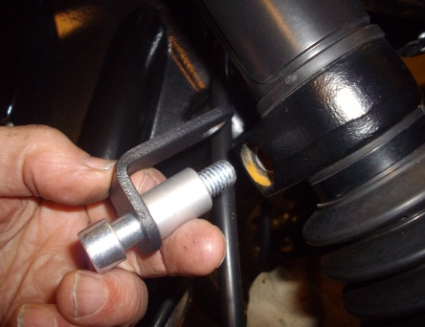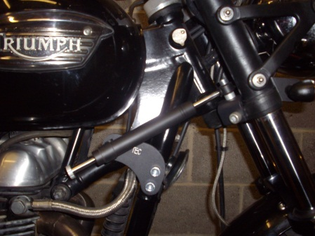

**Bracket A details**

**Damper kit fitted**

**Bracket B details**

**After installation check the steering moves freely from lock to lock. We recommend initially using the lowest setting (fully counter-clockwise) and riding the bike in a safe wide-open space until you accustom yourself to the bike’s new handling characteristics which will be most evident at slow speeds.**