www.TECbikepartsUSA.com

TRIUMPH STAND KIT

WARNING: Please use a qualified motorcycle mechanic to install the center stand. If you decide to perform the installation yourself, please ensure stand is fitted and checked before use by a competent person or technician. IMPORTANT: This stand was made to fit unmodified, stock bikes.

Make certain the bike is supported and secured correctly during stand installation and that all safety precautions are followed to avoid the bike falling and causing damage or injury.

With care it is possible to fit center stand whilst the bike is on its kick stand in 15minutes.

After installation, have a friend assist for a few operations of putting the bike on and off the stand to familiarize yourself with the operation.

Tools required: 17mm, 14mm, 13mm wrenches/sockets, extension bar, 6mm & 8mm Hex Key Wrenches (Allen Keys)

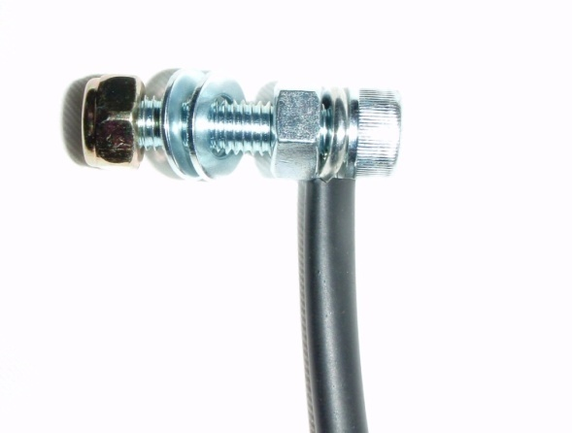
- Assemble bolt and spring as shown. Mount spring to frame of bike with the bolt. Use the 8mm hole in chassis located just below lower chain run approx 70mm forward and above right/hand stand mount hole. Tighten nyloc nut securely, allow some free movement of the spring. (SEE LAST PAGE FOR MORE PICTURES)

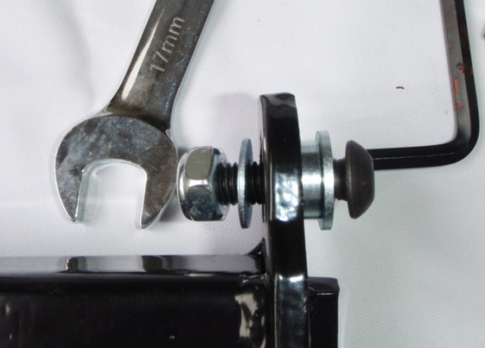
- Test-fit domed-headed 10mm bolt and spacer with collar to right-hand stand hole as shown.(head of bolt must be to outside of bike or it will foul spring). With bolt ready to fit, hook spring to stand and pull down stand to push through bolt. Fit washer and nut LOOSELY at this stage! Note that both stand lugs go to right side of frame lugs. [note added as many bikes are not like this arrangement]

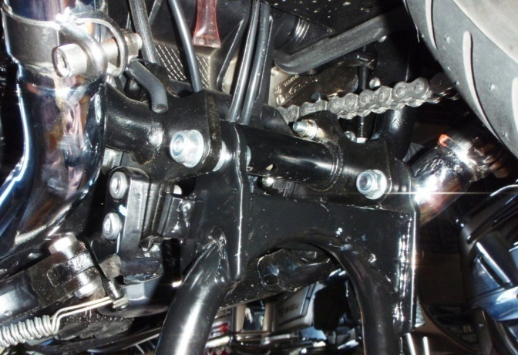
- Fit 10mm bolt and spacer to left/hand mount and tighten both the left and right-hand stand pivot bolts firmly but not securely. At this stage the stand should be free on its pivots, if the stand is binding then one of the top-hat bearings will require spacing out from the frame, slacken the left-hand bolt, if the stand stops binding then remove bolt and fit packing washer behind top-hat bearing, this should alleviate the issue, retighten all bolts.

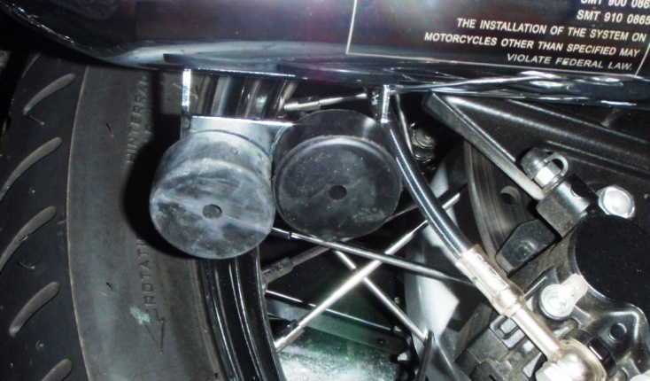
- Fit rubber stop to hole on left/hand silencer bracket (use soapy water or silicone spray lubricant). This does not apply to Scrambler models—See Below.

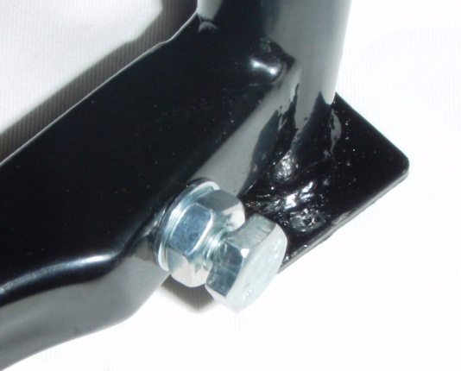
- Fit and adjust 8mm stop bolt in operating arm and adjust to required clearance.

- Check clearance to tire (runs close on one side-this is normal) and chain, and lubricate pivots with spray grease (chain lubricant works well)

- On Scrambler models fit the stand stop bracket with stop rubber to inside of left rear foot peg and position so that the adjustable stop bolt contacts the center of the stop rubber before tightening securely.

- Operate the stand a few times to centralize and align the mounting bolts. Now tighten the pivot bolts “SECURELY”

IMPORTANT: Lubricate pivots periodically and at service.

For an electronic copy of these instructions, please go to: www.TECbikepartsUSA.com

STAND SPRING PICTURES

